Nexus Aquarium

*User Guide*

|  |  |  |
| --- | --- | --- |
| **Supervisor.** | **Sir Hassan Nadeem** | |
| **Batch.** | **2202B1** | |
| **Group.** | A | |
| **Serial No.** | **Enrollment Number** | **Student Name** |
| 1. | 1364030 | Aiman Hussain |
| 2. | 1364699 | Areeba Shafi |
| 3. | 1362555 | Habiba Noor |
| 4. | 1363279 | Manahil Ilyas |



1. **Home** (*index (1).html*)

***Figure 1: Home page to durable furniture***

 Our Slogan has given to the peoples toward our website. “TO BUY FURNITURES AT THE CHEAPEST PRICE ”.

* OUR HOME PAGE WELCOME OUR CUSTUMERS WITH BEAUTIFUL QOUTE.

1. **Navbar (index.html)**

***Figure 2: Navbar***

We have given FIVE essentials. By clicking any of the essential’s and redirect to the linked page. (Index.html)

1. **MENU (index .html)**

***Figure 3: Menu***

**



* We give discount offers to our clients.
* They see different kinds of offers in which furniture they interested.
* There is a button given them to apply shopping online.by clicking on the button “SHOP”

**4.PRODUCTS (index .html)**

***Figure 4: Products***

*We have mentioned our basic products to make people known about the products we provide.*

* ***There we show such our comfortable chairs.***
* ***There our clients also see our premium quality cabinets ,Almirah and some dressers etc***

***5.NEW ARRIVALS (index .html)***



***Figure 5:***

***New arrivals***

*.*

***“Description of some new products”***

*We have given some unique kind of products in our arrival page*

*And provide hover to highlight the multi functional product so that people who are visiting our website can gain knowledge. We give a option there to add to cart ,add in favourites.and like options by hovering on them and then there they show some kinds of options there*

* ***Multi-functional sofa set 1***
* ***Multi-functional sofa set 2***
* ***Cube booth seat***
* ***Ergonomic chairs***

***6.Our clients review(index .html) :***

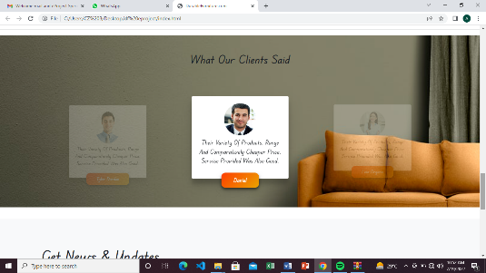



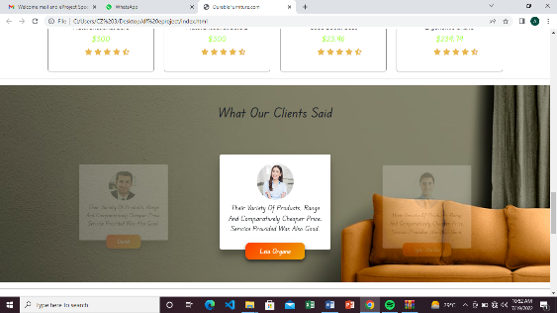



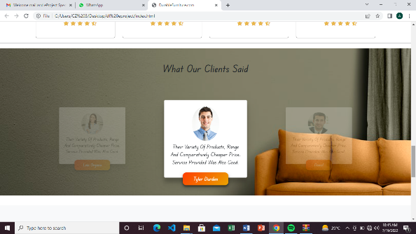

***7.subscribe section(index .html):***

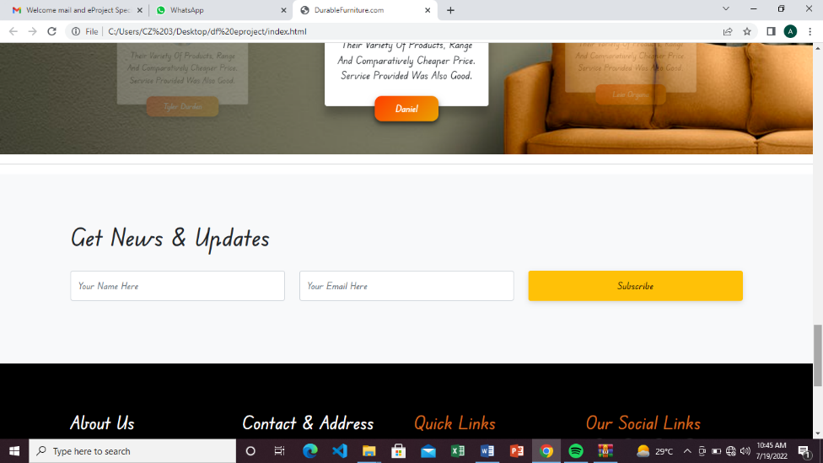

***Figure 7: subscribe section***

*Our subscribe section* is designed to notify about our new products and our prices and other policies are also mentioned there.

***8. login(login. Html):***

*On clicking login. Login form page open on blank page there customer show two buttons create account button and sing up button with these two options they can create their account or sing in if they have already an account****.***

***9.footer (index .html):***

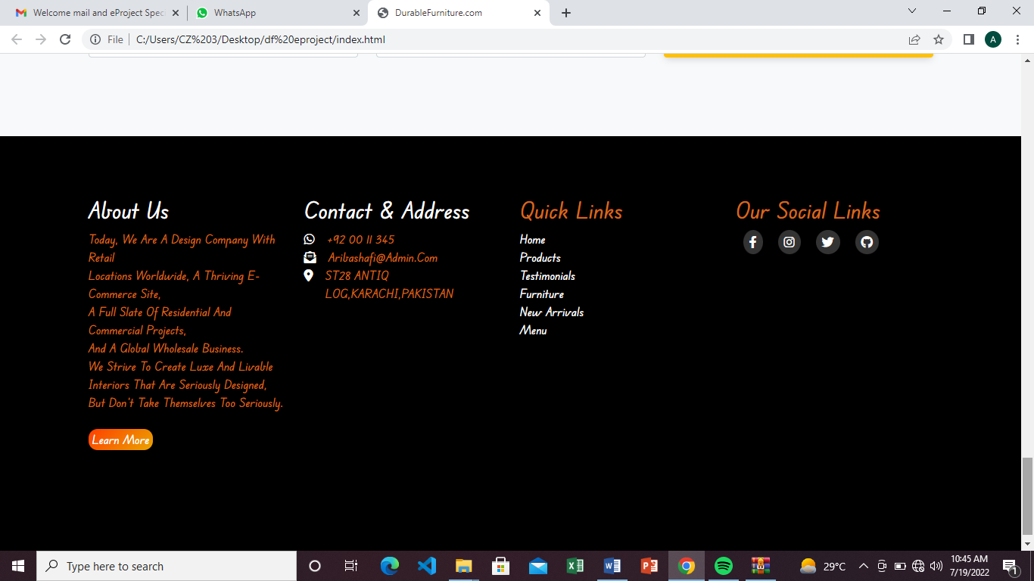

***Figure 14: Footer***

We have given some hover effects in footer to make our website more relaxing.

